
Initial Assessment

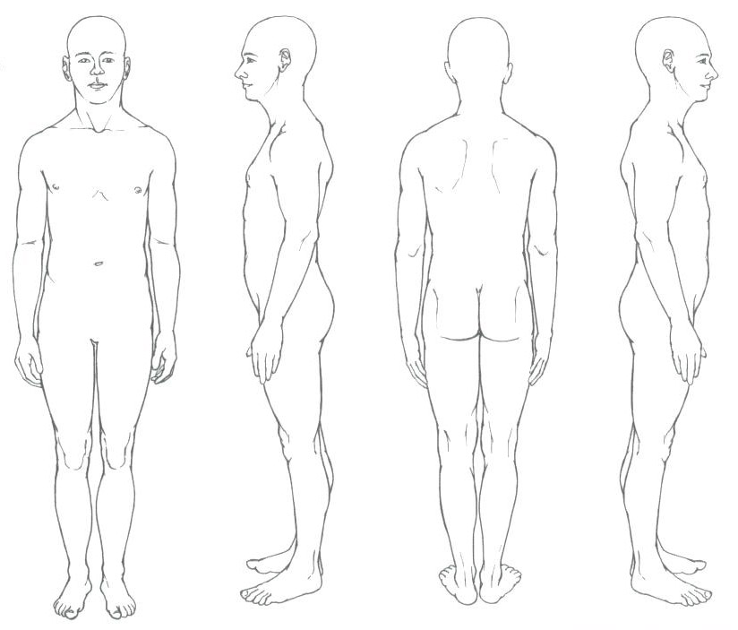

Comments: ________________________________________________________________
_________________________________________________________________________
_________________________________________________________________________
_________________________________________________________________________
_________________________________________________________________________
Legend

X Trigger Point
------ Level
<--> Long
@ Tender Spots
>--< Short
Tight Muscle
 Rotation
 Direction

